Instructions
All UAV flights must be cleared by the Drone Committee and this notification form shall include the full-text NOTAM(s).
- All requests shall be submitted to the UA Flight Coordinator a minimum of 24 hours in advance for review by the JHU Drone Committee.
  - This allows the publication and transmission to the responsible departments including Public Safety.
  - Flights are not considered to be cleared until a formal assignment of NOTAM by the FAA is received. They will be published on the FAA website approximately 36-48 hours before they are effective
- Pilot in Command is responsible for obtaining NOTAM(s) for the cleared flight(s). Multiple days can be flown under a single NOTAM filed in accordance with FAA requirements. If assistance is needed from the UAV Flight Coordinator submissions shall be submitted 60 hours before the scheduled flight time.
- You may submit multiple flight dates and times using the same plan (5 maximum) as long as all other information remains the same.
- Nighttime flights are now allowed under the following conditions
  - PIC’s Remote Pilot’s license has been issued after 21 April 2021.
  - UAV shall be operated with appropriate anti-collision lighting. Minimum weather visibility must be 3 miles from the control station.
  - UAV has Remote ID.
The PIC shall include necessary documentation in the flight plan demonstrating that these requirements are satisfied.

By submitting this flight plan to the Drone Committee, the Operator in Command and Principal Observer certify that they will:
- Comply with all
  - FAA Rules and Regulations at the time of submission.
  - JHU Policy on Use of Unmanned Aircraft Systems (JHU OPS007)
- safely conduct UAS operations.
- Advise the Drone Committee of any changes in flight and update NOTAMs as necessary.
- If the request is from a non-affiliate of the university or for a non-university function the following additional information must be supplied with each flight.
  - Documentation that the UAV(s) being flown are registered by providing their N-number
  - Documentation concerning their Remote ID status
  - Photocopies of the Operator in Commands Remote Pilot’s License
  - Photocopy of a picture identification card.
  - Proof of insurance.
FLIGHT PLAN SUBMISSIONS MUST BE DONE IN WORD FORMAT.

 | Crew Information
 | Name | Pilot License # | Cell number
Pilot in Command (required)
Principal Observer (required)
Additional Observer(s)
(Optional)
Reviewed by

NOTE: Always inform the Flight List that operations have been completed. You will receive a reminder with your Flight Clearance.

Planned Flight time(s)
Date(s):
Start:
Finish:
UAS Information
Model:
Serial Number:
N-Number:
UAS Remote ID Compliant? | YES / NO | YES / NO
Model:
Remote ID S/N
FAA NOTAM #

FULL NOTAM TEXT - ##############

Photos: of Drone:
TOP VIEW | SIDE VIEW

Flight Plan: Information provided is as an example only

- Purpose of flight - Aerial videography of Campus for University Communications Projects

- Proposed flight times (if the flight is after dark or before sunrise include documentation indicating the UA and PIC are qualified for these operations)

- Will the flight be over people? (If so provide documentation that the UA and PIC are qualified for Category 1, 2, or 3 operations) Specify Category Classification and the nature of those operations

- Maximum altitude – 150 ft

- Maximum distance from center location – 2000 ft

- Waypoints or detailed flight plan if available - TBD

- Maximum Speed – 10 mph (This is the maximum allowable ground speed over the campus.)

- Center of Flight Location – Be sure to include a screenshot showing latitude and longitude information.
Note: The center of JHU Homewood is at 39.3300° N, 76.6207° W (39° 19' 48.17" N, 76° 37' 14.56" W)
Possible Sources (see samples on next page).

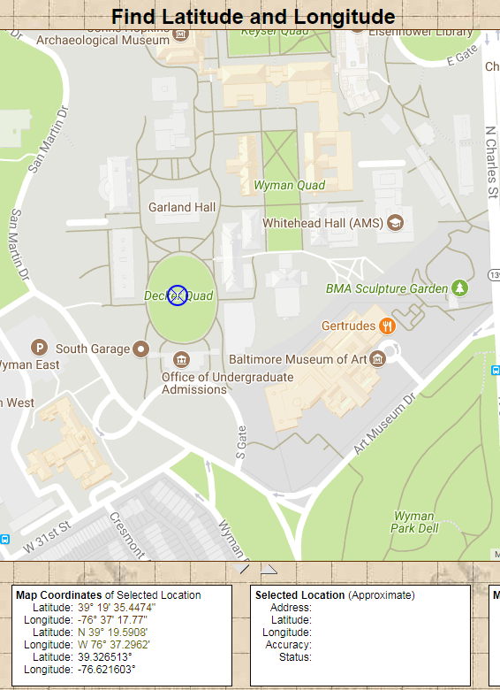 | 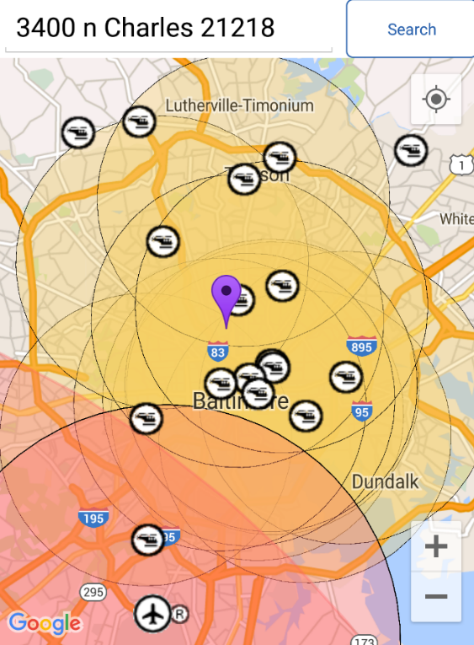
https://www.findlatitudeandlongitude.com/  Preferred | “Before you Fly” App

